H.T No
Regulations:
A20

Sreenidhi Institute of Science and Technology
(An Autonomous Institution)
Code No: 8BC02 Date: 23-Mar-2023 (AN)

B.Tech I-Year II- Semester External Examination, March/April-2023 (Supplementary)
ENGINEERING GRAPHICS - (CIVIL, ECE, CSE, CS, AI&ML, DS and IOT)

Time: 3 Hours Max.Marks:70

Note: a) No additional answer sheets will be provided.
b) All sub-parts of a question must be answered at one place only, otherwise it will not be valued.
c) Missing data can be assumed suitably.
Bloom's Cognitive Levels of Learning (BCLL)

Remember | L1 | Apply | L3 | Evaluate | L5
Understand | L2 | Analyze | L4 | Create | L6

Part - A Max.Marks:20

Answer all QUESTIONS.

 |  | BCLL | CO(s) | Marks
1 | Write systems used in placing of dimensions. | L1 | CO1 | [2M]
2 | Draw the symbol of first angle and third angle projection. | L2 | CO2 | [2M]
3 | Distinguish between frustum and truncated solid? | L2 | CO3 | [2M]
4 | State the principal methods of development of surfaces. | L1 | CO4 | [2M]
5 | Write the relation between isometric length and true length. | L1 | CO5 | [2M]
6 | List out some draw commands used in CAD. | L1 | CO6 | [2M]
7 | What is representative fraction. | L1 | CO1 | [2M]
8 | What are solids of revolution? Give examples. | L2 | CO3 | [2M]
9 | Explain isometric axes and isometric lines. | L2 | CO5 | [2M]
10 | Explain some fundamental commands used in CAD to edit a drawing. | L1 | CO5 | [2M]

Part – B Max.Marks:50
ANSWER ANY FIVE QUESTIONS. EACH QUESTION CARRIES 10 MARKS.

 |  |  | BCLL | CO(s) | Marks
11. |  | Draw an involute of a circle of 40 mm diameter. Also, draw a normal and a tangent to it at a point 100 mm from the center of the circle. | L1 | CO1 | [10M]
12. |  | A line AB, 80mm long, is inclined at 30° to the H.P. and its top view makes an angle of 60° with the V.P. The end A is in the H.P. and 12mm in front of V.P. Draw its front view and finds its true inclination with the V.P. | L1 | CO2 | [10M]
13. | a) | A regular pentagon of 25 mm side has one side on  the ground. Its plane is inclined at 45° to the H.P and perpendicular to the V.P. Draw its projections. | L3 | CO3 | [5M]
 | b) | Draw the projections of a hexagonal pyramid, base30 mm side and axis 60 mm long, having its base on the H.P. and one of the edges of the base inclined at 45° to the V.P. | L3 | CO3 | [5M]
14. |  | A cylinder of 40 mm diameter, 60 mm height and having its axis vertical, is cut by a section plane, perpendicular to the V.P., inclined at 45° to the H.P. and intersecting the axis 32 mm above the base. Draw  its front view and sectional top view. | L4 | CO4 | [10M]
15. |  | Draw the isometric view of a cylinder of 40 mm diameter & height 70 mm when its axis is in vertical and horizontal position. | L2 | CO5 | [10M]
16. |  | Draw the following views of the block shown pictorially.  (All dimensions are in mm) (i) Front view (ii) Top view  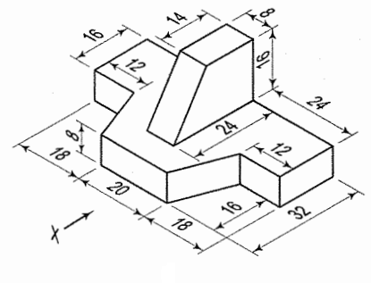 | L4 | CO6 | [10M]
17. |  | Construct a hyperbola, with a distance between the focus and the directrix as 65mm and eccentricity is 3/2 and draw normal and tangent to the curve at a point 35mm from the directrix. | L4 | CO1 | [10M]
18. |  | Draw the isometric view of a square prism, with side of base 40 and length of axis 70, when its axis is vertical. | L3 | CO4 | [10M]

-- 00 -- 00 –

